OLYMPIC DATASET POWER BI AND EDA REPORT

In this project, we explore how to analyze a large dataset of Olympic data with Power BI. We walk through the process of uploading the dataset, exploring its relationships, and analyzing the data for insights.

.

DATA DICTIONARY

|  |  |
| --- | --- |
| TABLE NAME | DESCRIPTION |
| CITY | City table has two columns id which is unique number for each city and city name which has name of all Olympic host city |
| COMPETITOR_EVENT | It contains event id and competitor id of person competing in various events and medal id |
| EVENT | It has unique id corresponding to each event and sports id |
| GAME | It has unique id correspond to each game ,game_year, game_name and season column which will tell us about type of Olympic game (summer or winter) |
| GAMES_CITY | It has two unique column of game id and city id correspond to game name and city name |
| GAMES_COMPITITOR | It has unique id correspond to each person id and game id in which person takes part also it has age column |
| MEDAL | It has unique id for each medal name |
| NOC_REGION | It has three column unique id for each region name and short form of each region name |
| PERSON | It has unique id which is person id , full name of person ,gender ,height and weight |
| PERSON_REGION | It has two column person id and region id |

|  |  |
| --- | --- |
| SPORT | It has two column ,unique id and sports name |
| FINAL_FACT OR CONSOLIDATED_FACT | It has all the merge column of above table |

**Uploading Data in Power BI**

Uploading data is an essential step in analyzing data in Power BI. In this project, we explore how to upload 11 csv files to Power BI.

To upload the data, navigate to the "Get Data" tab and select "Text/CSV". Then, select the csv file you want to upload.

**Exploring the Relationship Between the Tables**

Understanding the relationship between tables is the key to unlocking insights in complex data. In this project, we explore the relationships within the Olympic data tables.

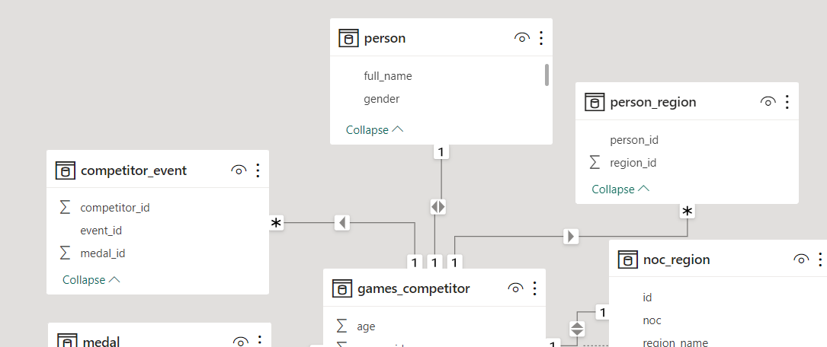

**Identifying the Lack of Organized Relationship**

Before we can analyze data, we must identify the lack of organized relationships between tables. In this project, we identify and explore the lack of organized relationships within the Olympic data tables

**No Clear Relationship-**The Olympic data tables had no clear, organized relationships, making it difficult to perform in-depth analysis.

**Identifying the Issue-**The data modeling view helped us to identify the problem and visualize the relationships between the tables**.**

**Resolution-By** understanding the relationships, we were able to build a data model and perform more advanced analysis**.**

**Making of Olympics Data Visualization**

The ever-evolving Olympic data set serves as a fascinating case study on sports and athletic performance. The mammoth collection of records, including athlete profiles and event outcomes, presents a wealth of opportunities for visual storytelling. To ensure that the data speaks to the viewer, an outstanding visualization plan must be developed and implemented

# Preparing and Cleaning the Data for Visualization

To create engaging Olympic data visualization, you must first prepare and clean the dataset. This might involve selecting the relevant variables and limiting the dataset to specific Olympics or events. Cleaning the data is necessary to identify and handle null or missing values and to remove duplicates and inconsistencies. Once the data is cleaned, it should be restructured in a way that simplifies chart generation and better highlights key points.

In this process we have added one conditional column known as age group to evaluate the age competitors lying in which age category .

Further we have made measures to ease the calculation required during making visuals.

# Creating Tables and Charts

### Tables

The Olympic data set is rich in tabular data that is ideal for generating tables. Tables can help visualize relationships, compare fields, show statistics, and showcase individual performance across Olympic events

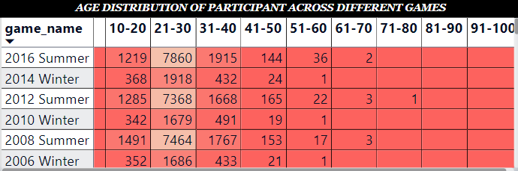

### Charts and Diagrams

If you're looking to create beautiful, succinct, and engaging visual summaries, consider charts or diagrams. Charts and diagrams are unambiguous and straightforward, capable of highlighting major trends, comparing data, and presenting powerful statistics with ease.

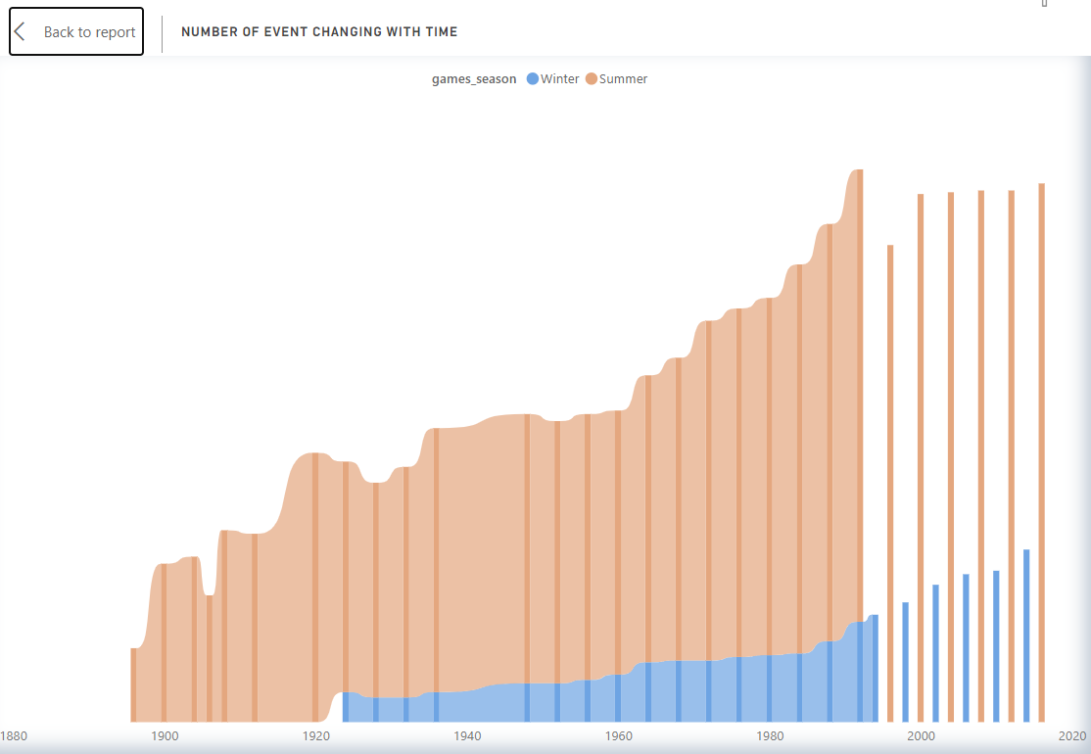

# Dashboard Design

In this section, we will delve into the design aspects of the dashboard. Discover how to define clear objectives, select appropriate charts and tables, and arrange them effectively to provide an intuitive and visually appealing visualization of the data

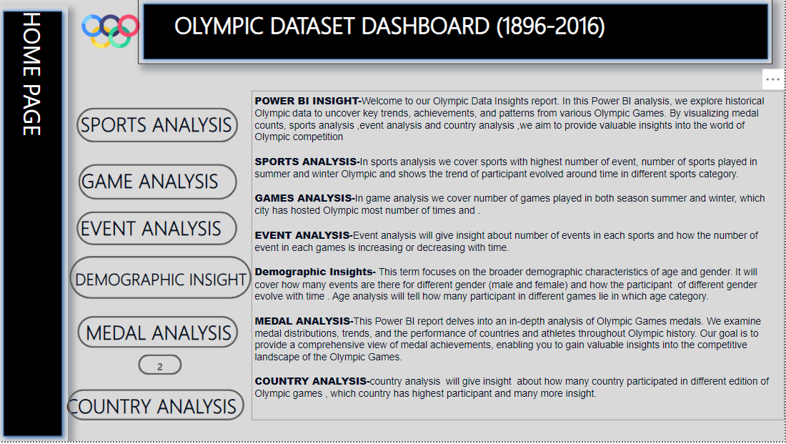In the making of dashboard we have use page navigation to navigate between different pages of dashboard. We have made different pages like home page(all the information of relevant page is there)

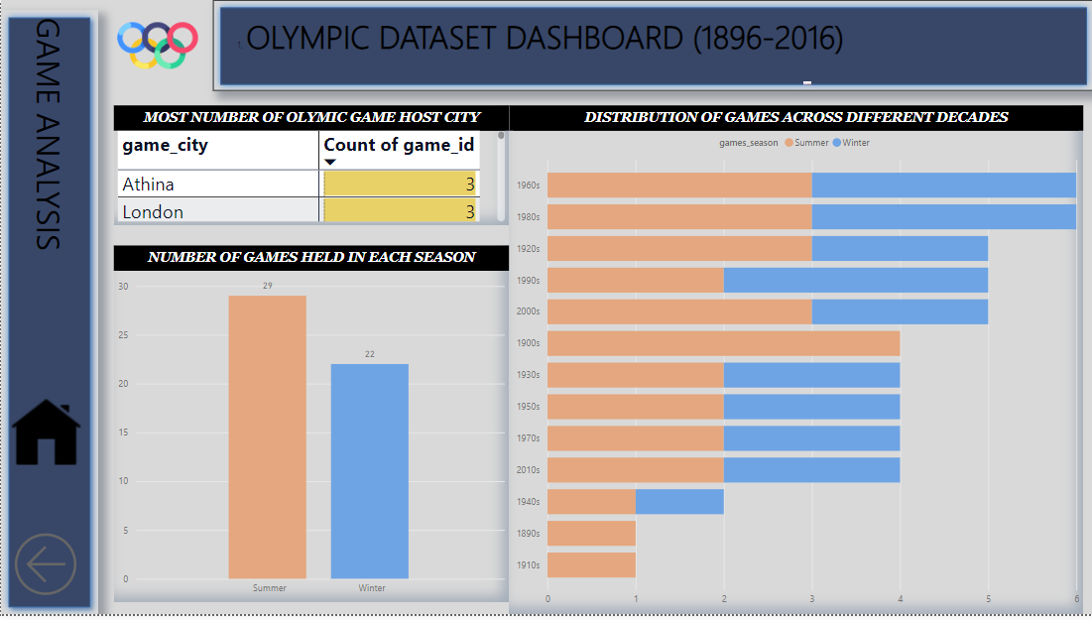Games analysis page-

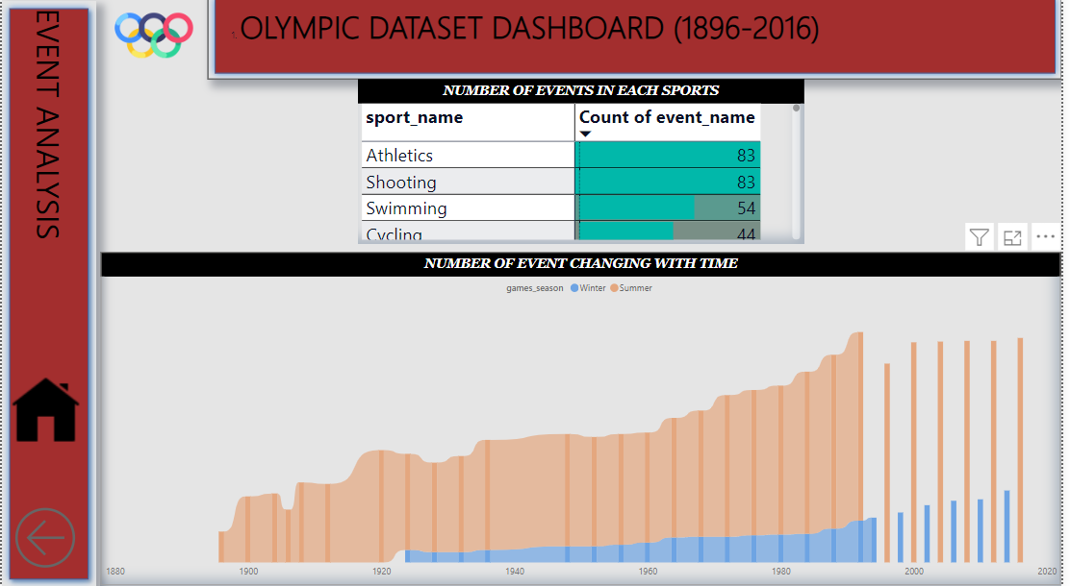Event analysis page-

Demographic insight page -

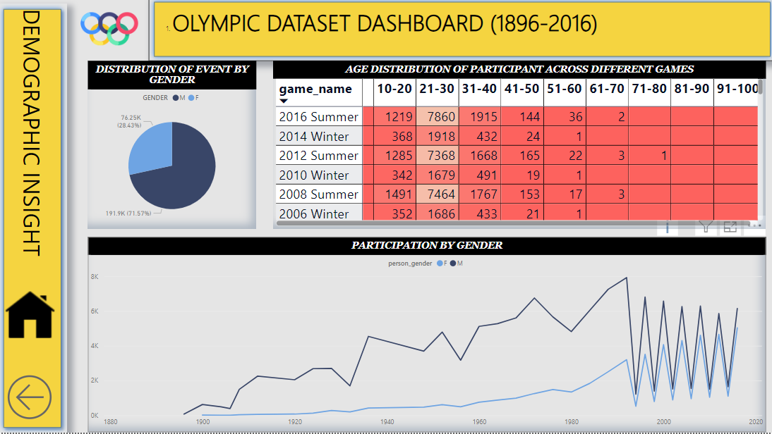

Medal analysis-

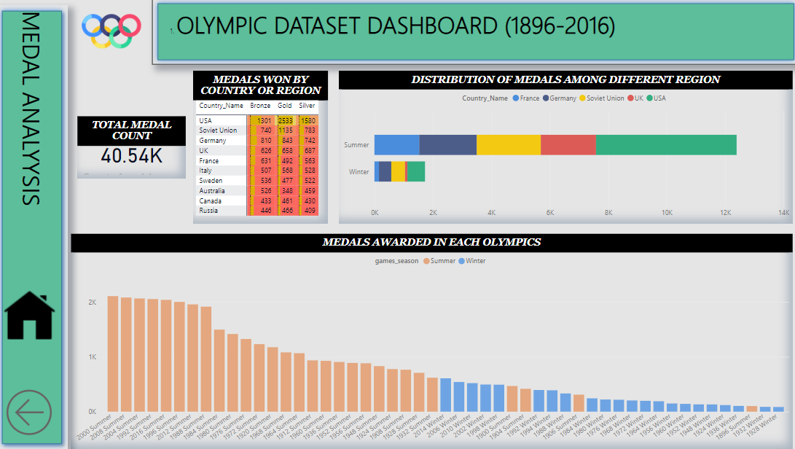

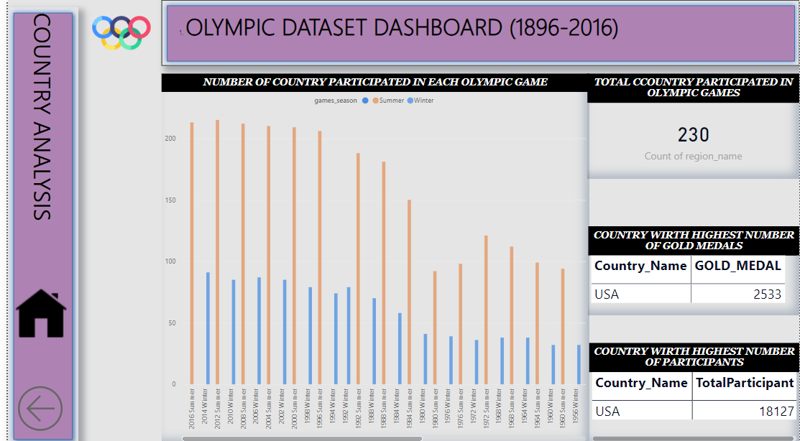Country analysis-

EDA ANALYSIS

The pivot table and pivot chart are powerful tools for analysing data. This section explains how they work and why they are essential for drawing insights from the Olympic dataset

"A pivot table is like a summary table that lets you analyse and reorganize data by dragging and dropping fields. A pivot chart is a graphical representation of a pivot table that can be used to visualize large amounts of data." - Microsoft

### The pivot table

Pivot tables enable you to analyse large datasets quickly and easily. By stacking and sorting data, pivot tables can reveal trends and patterns that might otherwise be missed.

### The pivot chart

Pivot charts are a visual representation of pivot tables. They make it easy to spot trends, compare data, and draw insights. With a pivot chart, you can see the data in a way that makes sense and provides context.

# The Analysis

By using pivot tables and charts, this analysis reveals insights that might not be apparent at first glance. This section examines key variables such as country, sport, and medal count, and compares performance across different Olympic games.

|  |  |
| --- | --- |
| Variable | Insights |
| Country | Some countries consistently perform well across a range of sports, while others excel in specific areas. |
| Sport | The popularity of different sports has evolved over time, with newer and more diverse sports being added to the program. |
| Medals | There is a clear correlation between high-performing countries and high medal counts, but there are exceptions and outliers that warrant further investigation. |

# The Results

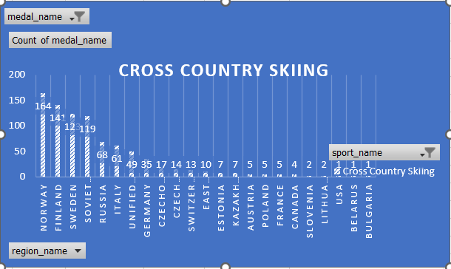After conducting the analysis, it's time to summarize the results and present them in a visually appealing way. This section provides an overview of the main findings and showcases the power of pivot charts.

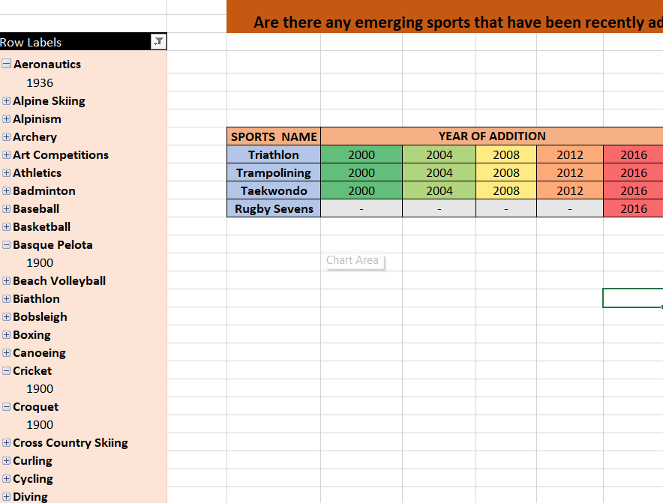PIVOT TABLE

# The Conclusion

By using pivot tables and charts, this Eda analysis of the Olympic dataset provides a unique perspective on the data and delivers valuable insights. This section summarizes the findings and discusses the potential implications of the research.

#### Key Takeaways

Overall, this analysis revealed that certain countries dominate the Olympic Games, while others struggle to compete. The popularity of individual sports also varies over time, and new sports are continually being added to the program. By using pivot tables and pivot charts, it's easier to spot trends and patterns in the data and draw conclusions from the information.

